AWS Lambda Function with CDK in Java &

Project Setup

- Project Structure :
- Project will be a multi module maven project.
- Functions module will have Lambda code.
- Infra module will have the CDK code.
- Assets folder will be created dynamically to store the jar/zip file from the Shades plugin used in POM.
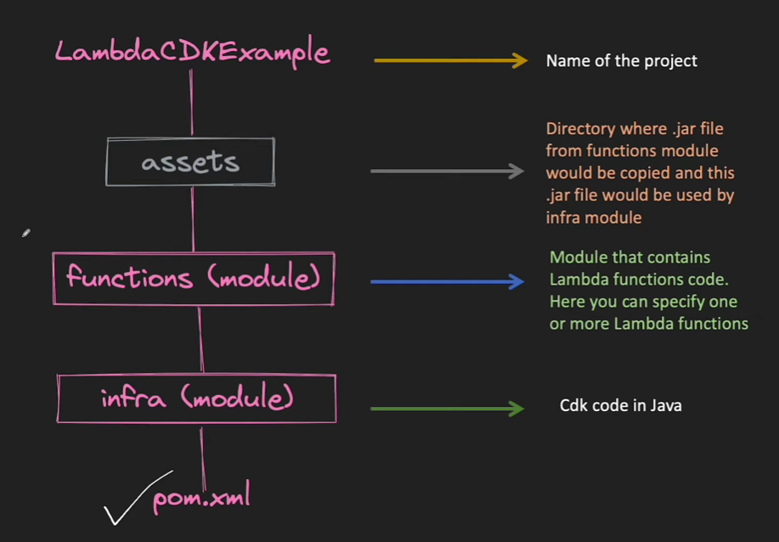

- Intellij -> new project -> {Provide Name / Language=Java / BuildType = Maven / JDK=17} {Additional Setting: Group-id and Artifact-id}
- Since we want a multi-model project..
  - Delete the SCR directory
  - Right click on the project and create a new Module.
  - Select maven -> quickstart (from archetype)
  - Name this module as ‘functions’
  - Add dependencies for AWS Lambda in Function Module POM.
    - Right click on POM -> Generate -> Add Dependency -> search for dependency
    - Group-id:artifact-id
    - Com.amazonaws:aws-lambda-java-core
  - Now we can create a class in Function module that implements RequestHandler interface.
  - We now need to add the Shades plugin to Function module POM.
<build>
<plugins>
<plugin>
<groupId>org.apache.maven.plugins</groupId>
<artifactId>maven-shade-plugin</artifactId>
<version>3.6.1</version>
<executions>
<execution>
<phase>package</phase>
<goals>
<goal>shade</goal>
</goals>

</execution>
</executions>
<configuration>
<finalName>function</finalName>
<outputDirectory>../assets</outputDirectory>
</configuration>

</plugin>
</plugins>
</build>

  - Now goto Terminal -> cd functions -> (in functions ) mvn clean package
  - Upon successful build it will create assets directory within the project and will have function.jar file in it.
  - Create a directory ‘infra’ in the project
  - Goto terminal -> cd infra
  - cdk init app –language=java
  - after successful cdk build, goto intellij, goto parent POM and add <module>infra</module>.
  - Note: to run the cdk , we must have Bootstrap already done once. Check first cdk application for bootstrapping.
  - Before we start with the CDK code, we need to build the base/parent POM, so that all dependencies are loaded.
  - Terminal -> cd to root project -> mvn clean install
  - It will build both the modules.
  - Create your CDK stack.
  - Terminal -> cd infra -> cdk synth
  - Cdk deploy
  - View the changes/stack on AWS Consol
- For any code change in lambda
  - Make code changes
  - Terminal -> cd functions -> mvn clean package
  - Cd .. -> cd infra
  - Cdk diff -> Cdk deploy

Sample Lambda Code:
public class LambdaExample implements RequestHandler<String, String> {
@Override
public String handleRequest(String user, Context context) {
return "Hello " + user;
}
}

Sample Infra/CDK Code:
public class InfraStack extends Stack {
public InfraStack(final Construct scope, final String id) {
this(scope, id, null);
}
public InfraStack(final Construct scope, final String id, final StackProps props) {
super(scope, id, props);
// The code that defines your stack goes here
// example resource
// final Queue queue = Queue.Builder.create(this, "InfraQueue")
// .visibilityTimeout(Duration.seconds(300))
// .build();
// Creating a Lambda function
Function.Builder.create(this, "cdk-simplelambda-example")
.runtime(Runtime.JAVA_17)
.handler("com.awsexamples.LambdaExample")
.memorySize(128)
.timeout(Duration.seconds(20))
.functionName("cdksimplelambdaexample")
.code(Code.fromAsset("../assets/function.jar"))
.build();
}
}

